WebSeries Analytics

**1.** import pandas as pd

import numpy as np

import matplotlib.pyplot as plt

import seaborn as sns.

**2.dataset = pd.read_excel("2255872-anime_data.xlsx")**

**3.dataset.head(2)**

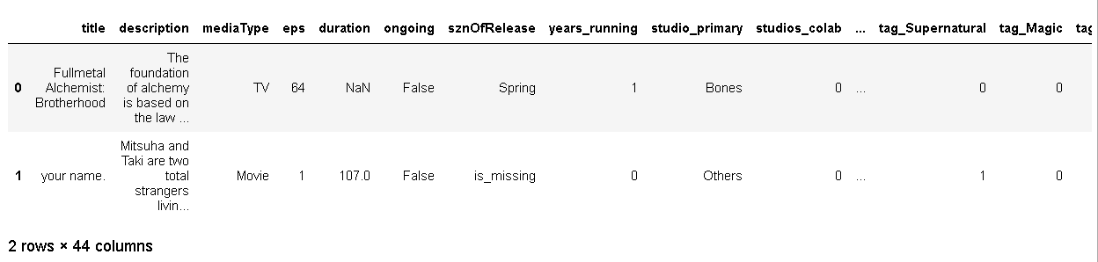

**4.dataset.shape**

**Ans: (12101, 44)**

**In [5]:**

**5.dataset.eps.describe()**

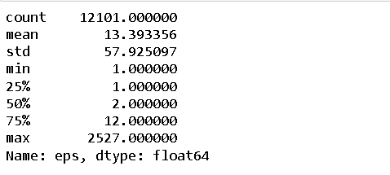

**6.dataset.columns**

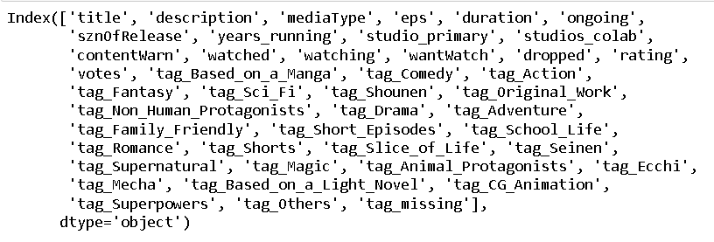

**7.dataset[(dataset['eps'] > 24) & (dataset.duration.isna())].shape**

**Ans: (1493, 44)**

**8.dataset_excluding_out = dataset[dataset['eps'] < 50]**

**9.dataset_excluding_out['eps_brackets'] = pd.cut(dataset_excluding_out['eps'], bins = [1,10,20,30,40,50],\**

**labels = ['cat1','cat2','cat3','cat4','cat5'])**

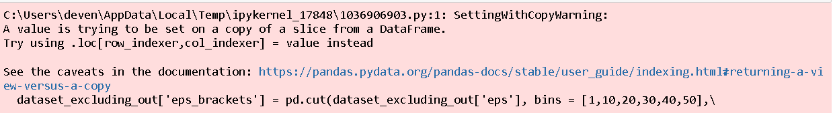

**10.dataset_excluding_out.shape**

**Ans:(11388, 45)**

**11.dataset_excluding_out.groupby(['eps_brackets']).duration.mean()**

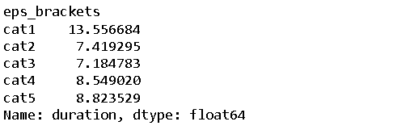

**12.dataset_excluding_out.groupby(['eps_brackets']).title.count()**

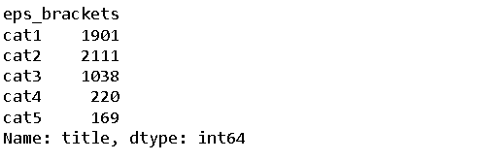

**13.dataset_excluding_out[dataset_excluding_out**

**['eps_brackets'] == 'cat1'].shape.**

**Ans:(1901, 45)**

**14.dataset[(dataset['eps'] < 24) & (~dataset.duration.isna())].describe()**

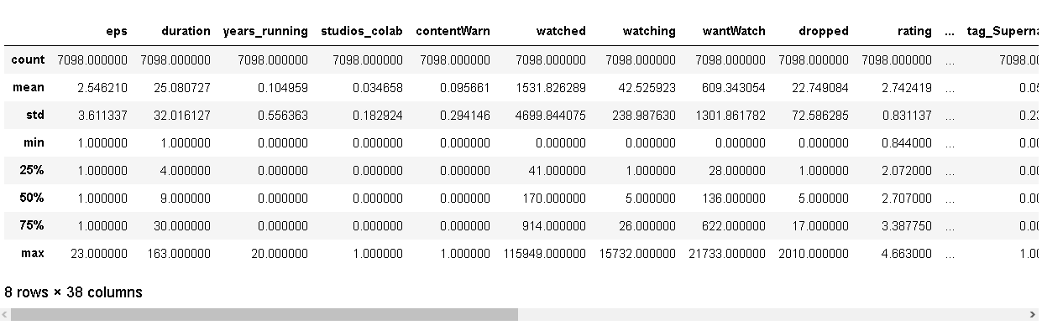

**15.dataset_excluding_out.groupby('mediaType')**

**.agg({'duration':'mean','mediaType':'count'})**

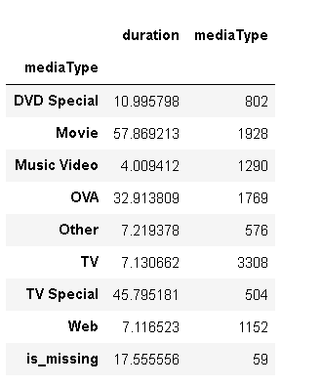

**16.dataset.isna().sum()**

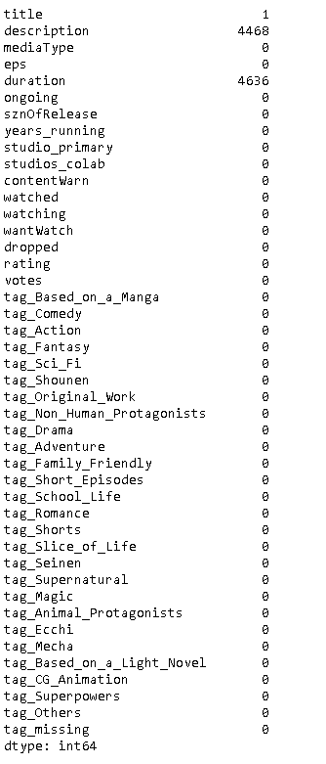

**17.dataset.info()**

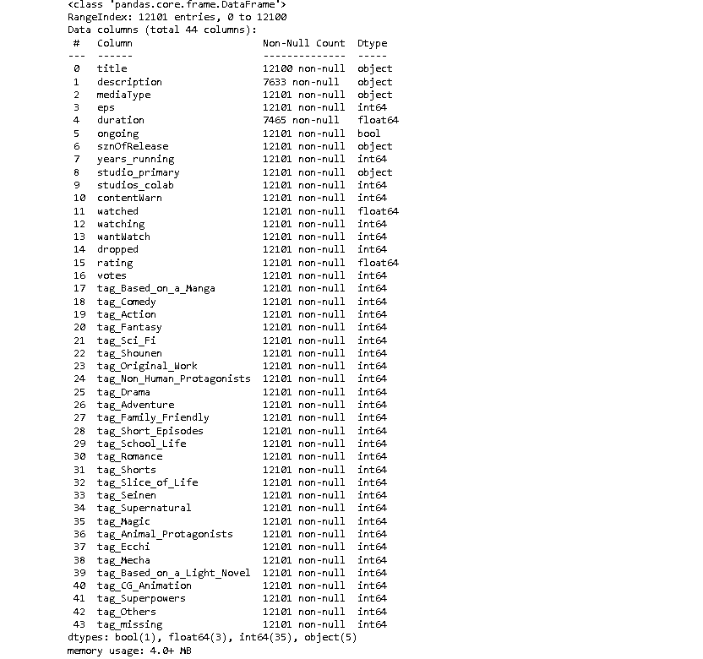

**18.dataset.describe().T**

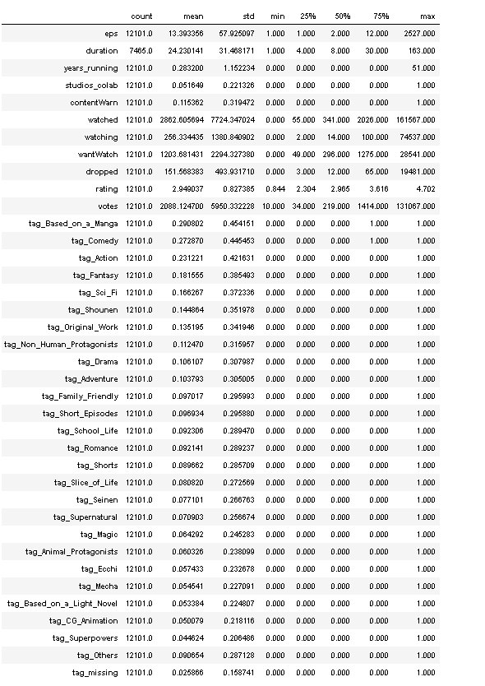

**19.dataset.drop(columns = ['title','description'], axis=1, inplace=True)**

**20.dataset.head()**

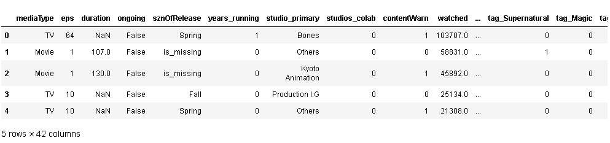

**21.dataset.rating.describe()**

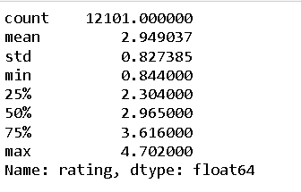

**22.dataset.dropna(inplace=True)**

**dataset.shape**

**Ans:(7465, 42)**

**23.dataset.columns**

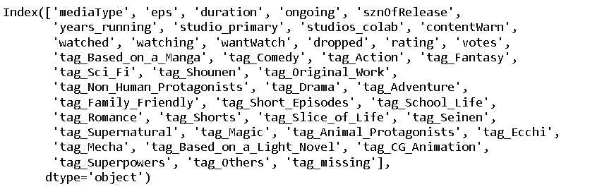

**24.def continuous_univariate_analysis(data,**

**feature,**

**figsize=(12,8),**

**kde=False,**

**bins=None):**

**f1, (ax_box,**

**ax_hist) = plt.subplots(nrows=2,**

**sharex=True,**

**gridspec_kw={'height_ratios': (0.25,0.75)},**

**figsize=figsize)**

**sns.color_palette("viridis", as_cmap=True)**

**sns.boxplot(data=data,**

**x=feature,**

**ax=ax_box,**

**showmeans=True,**

**color='yellow')**

**sns.histplot(data=data,**

**x=feature,**

**ax=ax_hist,**

**showmeans=True,**

**color='crest',**

**bins=bins,**

**kde=kde) if bins else sns.histplot(**

**data=data, x=feature, ax=ax_hist, kde=kde, color='blue')**

**ax_hist.axvline(data[feature].mean(), color='cyan', linestyle='--')**

**ax_hist.axvline(data[feature].median(), color='orange', linestyle="-")**

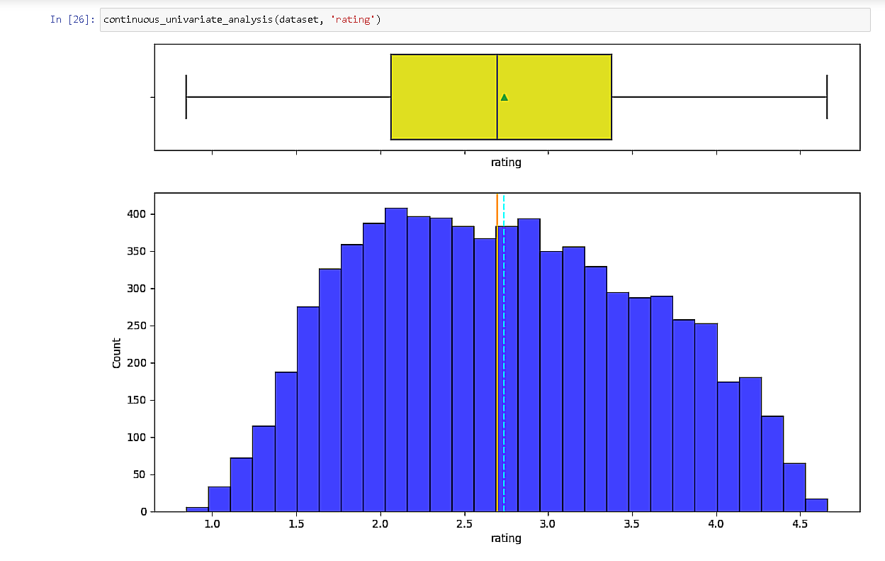

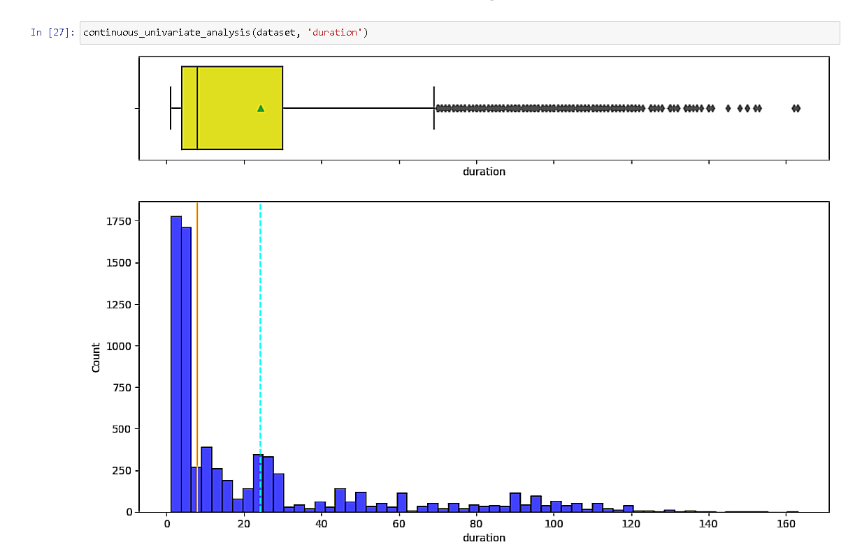

**25.dataset[dataset['duration'] >=80]['rating'].mean()**

**Ans:3.5694732254047326.**

**26.dataset[dataset['duration'] >=100]['rating'].mean()**

**Ans:3.729269121813031.**

**27.dataset[dataset['duration'] >=110]['rating'].mean()**

**Ans:3.7585191256830606.**

**28.dataset[(dataset['duration'] >=5) & (dataset['duration']<=30)]['rating'].mean()**

**Ans:2.7890469755469756.**

**29. def discrete_univariate_analysis(data, feature, perc=False, n=None):**

**total = len(data[feature])**

**count = data[feature].nunique()**

**if n is None:**

**plt.figure(figsize=(count + 1, 5))**

**else:**

**plt.figure(figsize=(n + 1, 5))**

**plt.xticks(rotation=90, fontsize=15)**

**ax = sns.countplot(**

**data=data,**

**x=feature,**

**palette="flare",**

**order=data[feature].value_counts().index[:n].sort_values(ascending=False))**

**for p in ax.patches:**

**if perc == True:**

**label = "{:.1f}%".format(100 * p.get_height() / total)**

**else:**

**label = p.get_height()**

**x = p.get_x() + p.get_width() / 2**

**y = p.get_height()**

**ax.annotate(label, (x, y),**

**ha="center",**

**va="center",**

**size=12,**

**xytext=(0, 5),**

**textcoords="offset points")**

**plt.show()**

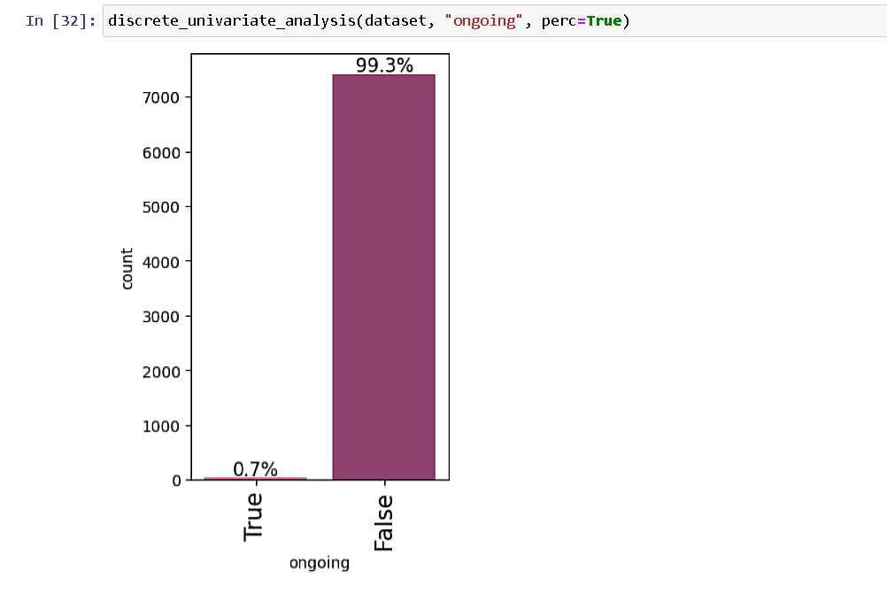

**30.dataset[dataset['ongoing'] == True]['rating'].mean()**

**Ans:3.1624600000000003**

**31.dataset[dataset['ongoing'] == True]['duration'].mean()**

**Ans:8.94**

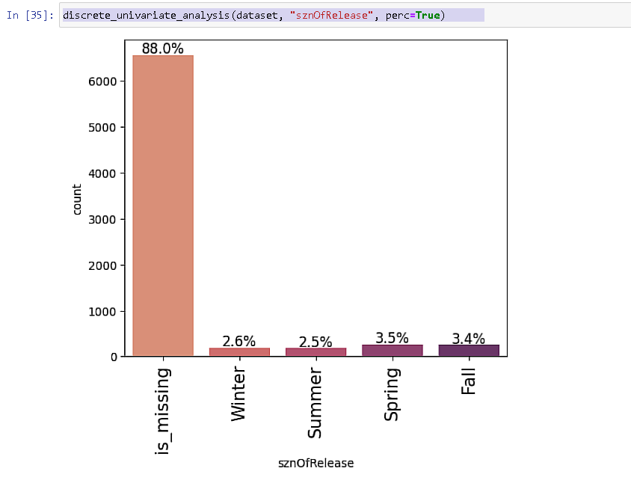

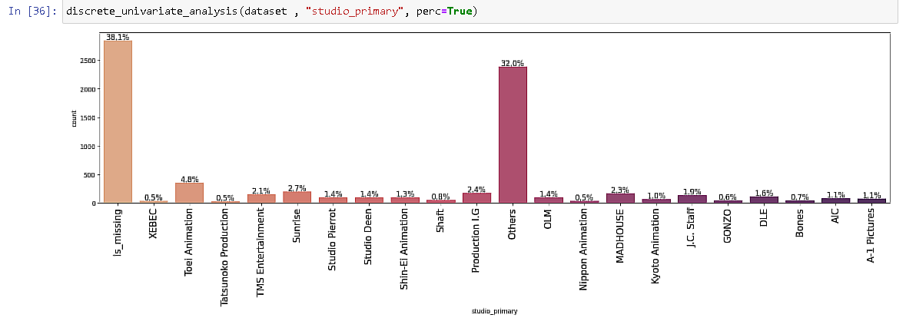

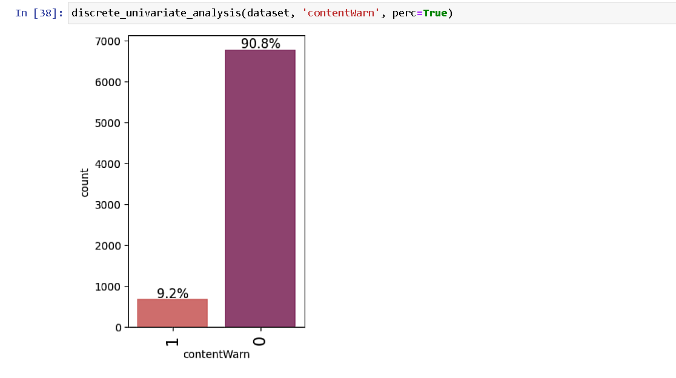

**32. dataset[dataset['rating'] > 4] ['studio_primary'].value_counts(normalize=True).mul(100).round(2)**

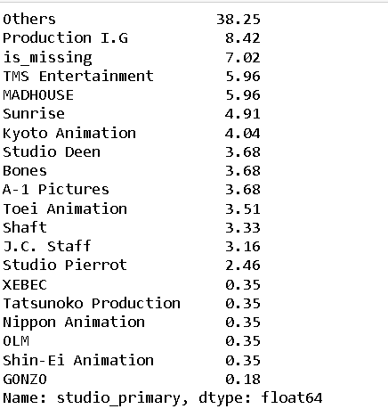

**33.corr_cols = [item for item in dataset.columns if "tag" not in item]**

**34.corr_cols//calling number 33 function**

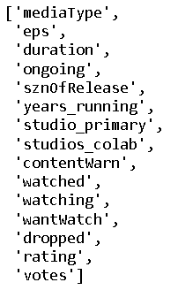

**35.plt.figure(figsize=(16,7))**

**sns.heatmap(dataset[corr_cols].corr(), annot=True, vmin = -1, fmt=' .2f', cmap='Spectral')**

**plt.show()**

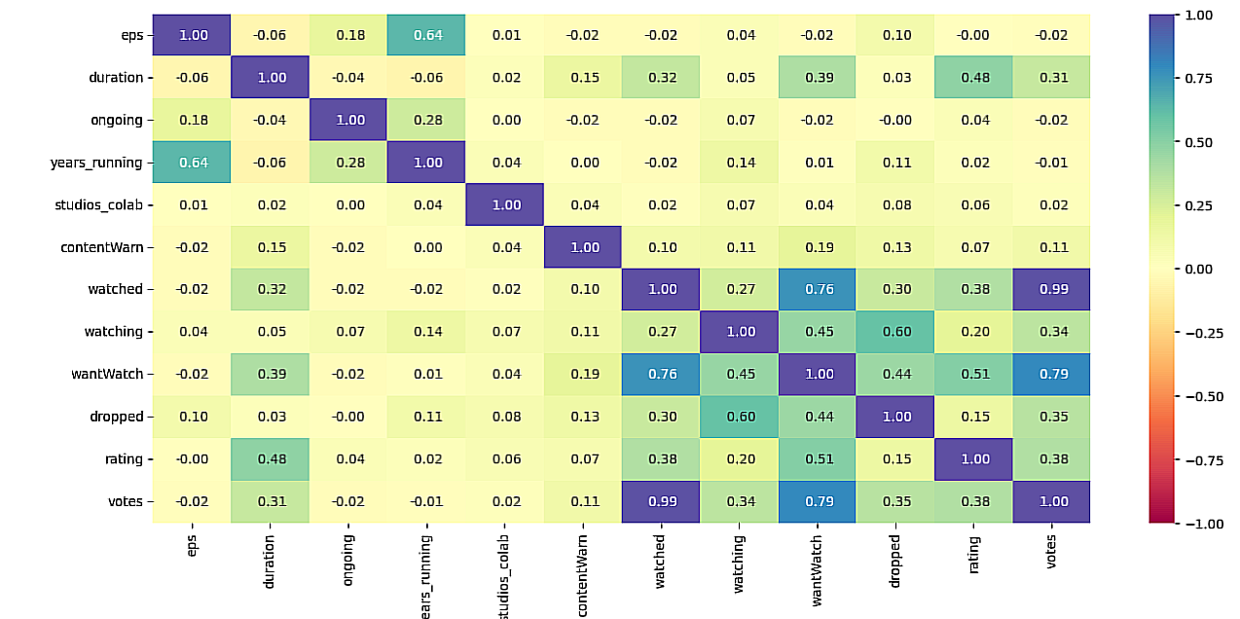

**36.dataset.drop(columns= ['eps', 'watched'], inplace=True)**

**37.dataset.shape**

**Ans:(7465, 40)**

**38.plt.figure(figsize=(15,8))**

**sns.boxplot(x = 'sznOfRelease', y='rating', data=dataset)**

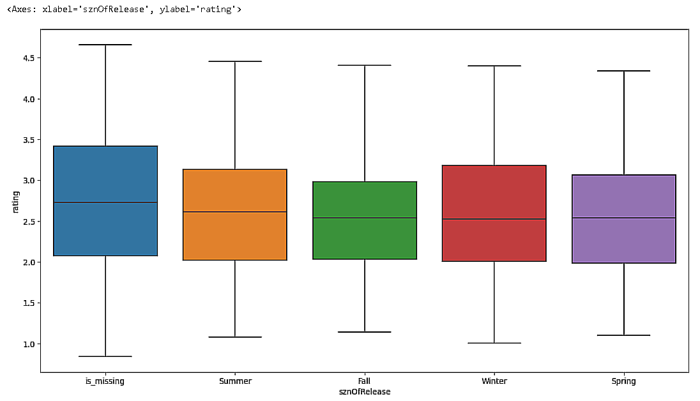

**##Model Building - Regression**

**39.x = dataset.drop(['rating'], axis=1)**

**y = dataset['rating']**

**40.x.info()**

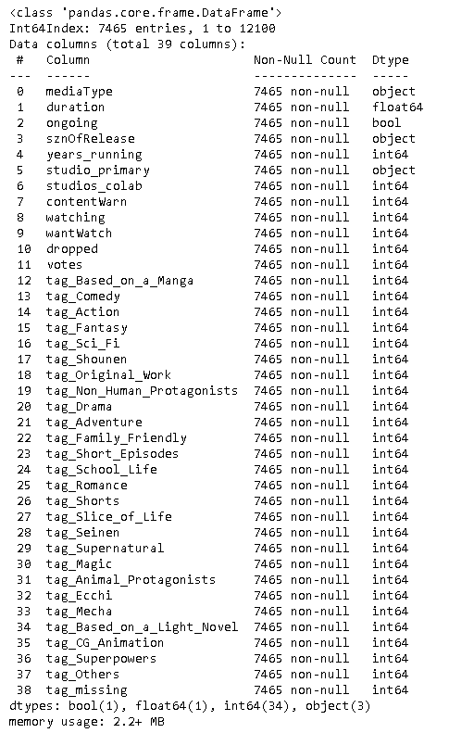

**41.**

**x = pd.get_dummies(x, columns=x.select_dtypes(include=['object', 'category']).columns.tolist(), drop_first=True)**

**x.head()**

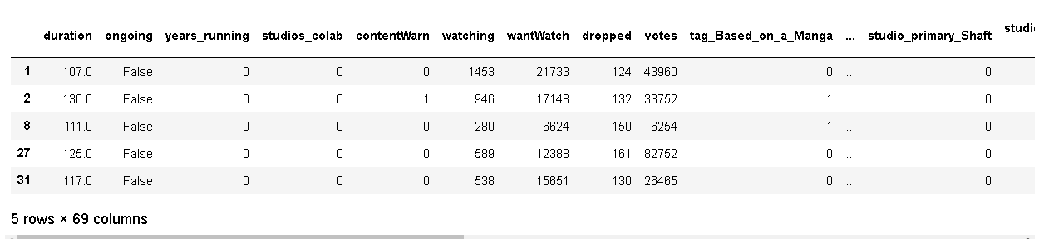

**42.x.drop(columns='ongoing', inplace=True)**

**43.x.drop()**

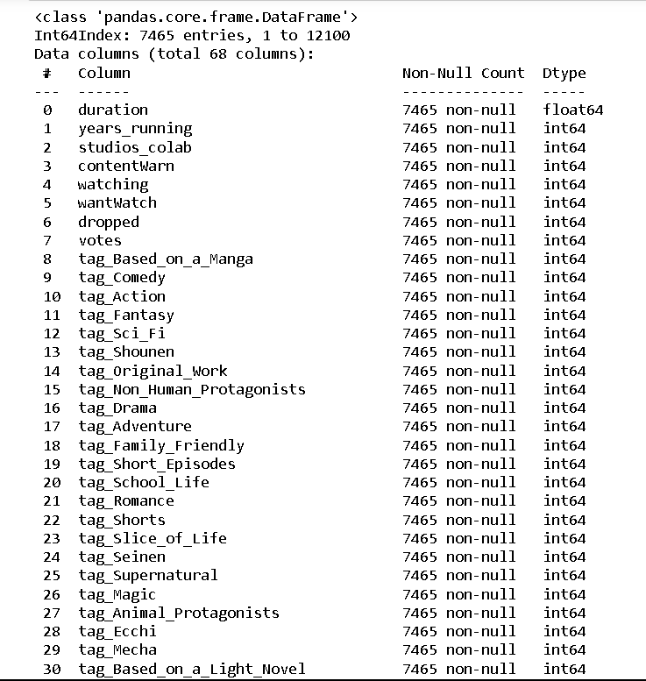

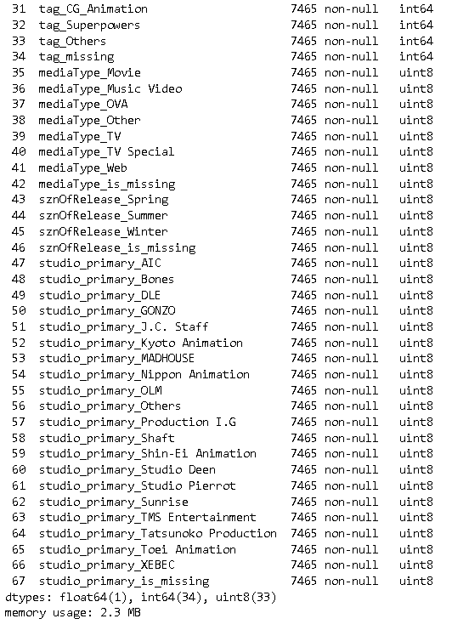

**44.from sklearn.model_selection import train_test_split**

**from sklearn.linear_model import LinearRegression**

**from sklearn.metrics import mean_squared_error, r2_score,**

**mean_absolute_error**

**45. X_train, X_test, Y_train, Y_test = train_test_split**

**(x,y, test_size=0.2, random_state=1)**

**46.print("Number of samples for train", X_train.shape[0])**

**print("Number of samples for test", X_test.shape[0])**

**Ans: Number of samples for train 5972**

**Number of samples for test 1493.**

**47.lin_model = LinearRegression()**

**lin_model.fit(X_train, Y_train)**

**Ans:**

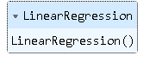

**48. def Model_performance(model, predictor, target):**

**pred = model.predict(predictor)**

**r2 = r2_score(target, pred)**

**rmse = np.sqrt(mean_squared_error(target, pred))**

**results= pd.DataFrame({**

**"RMSE":rmse,**

**"R2 Score":r2**

**}, index=[0]**

**)**

**return results**

**49.print("Training Data Performance")**

**lin_model_train = Model_performance(lin_model, X_train, Y_train)**

**Lin_model_train**

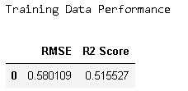

**50.x.columns**

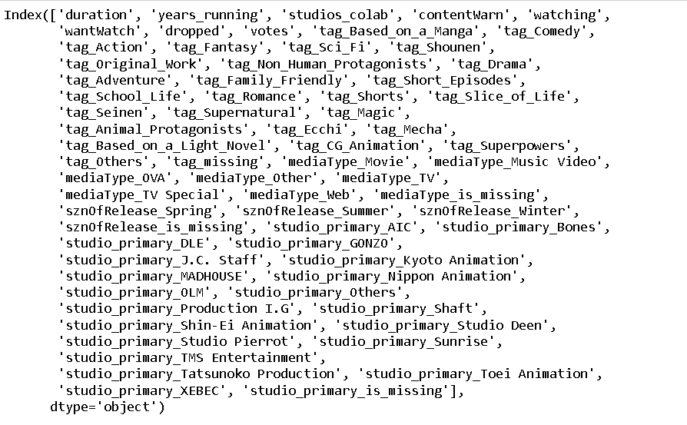

**##feature selection technique**

**51.conda install mlxtend //downloading mlxtend**

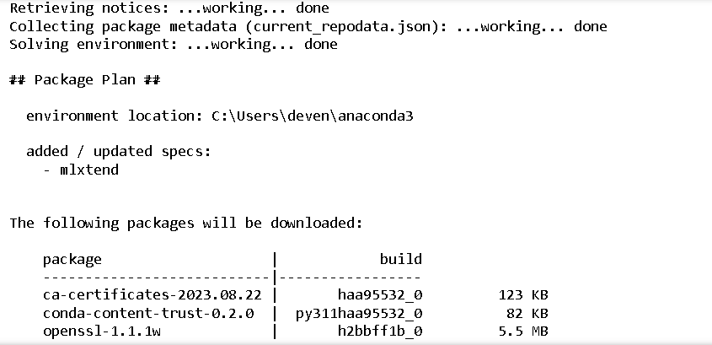

**52.1.**

**from mlxtend.feature_selection import SequentialFeatureSelector as SFS**

**reg = LinearRegression()**

**sfs = SFS(reg, k_features = X_train.shape[1],**

**forward = True, floating=False, scoring='r2', n_jobs= -1, cv=5)**

**sfs = sfs.fit(X_train, Y_train)**

**52.2.**

**from mlxtend.plotting import plot_sequential_feature_selection as plot_sfs**

**fig1 = plot_sfs(sfs.get_metric_dict(), kind='std_err', figsize=(15,5))**

**plt.title("Feature Selector - SFS")**

**plt.xticks(rotation=90)**

**plt.show()**

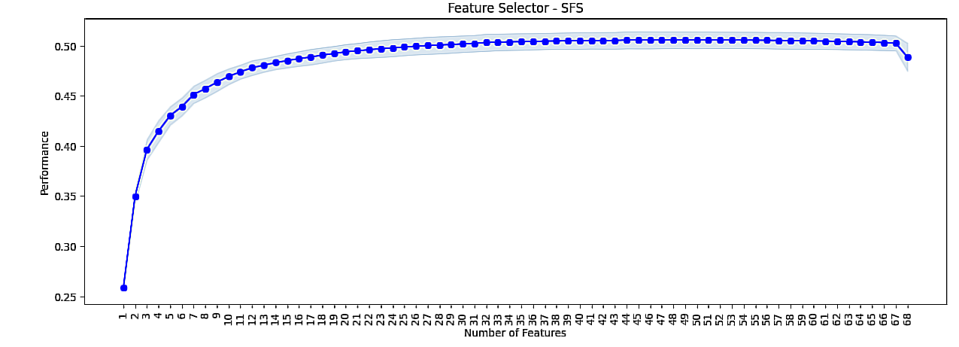

**53.1.**

**from mlxtend.feature_selection import SequentialFeatureSelector as SFS**

**reg = LinearRegression()**

**sfs = SFS(reg, k_features = 30,**

**forward = True, floating=False, scoring='r2', n_jobs= -1, cv=5)**

**sfs = sfs.fit(X_train, Y_train)**

**53.2.**

**from mlxtend.plotting import plot_sequential_feature_selection as plot_sfs**

**fig1 = plot_sfs(sfs.get_metric_dict(), kind='std_err', figsize=(15,5))**

**plt.title("Feature Selector - SFS")**

**plt.xticks(rotation=90)**

**plt.show()**

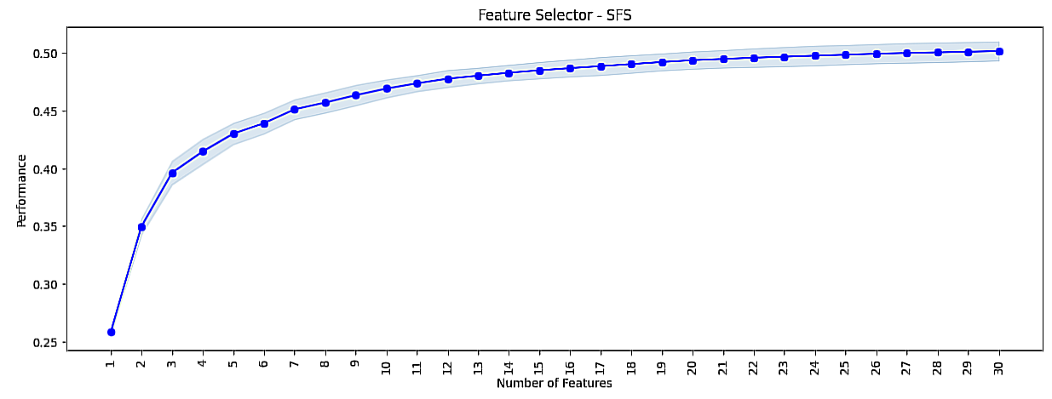

**54.1.**

**from mlxtend.feature_selection import SequentialFeatureSelector as SFS**

**reg = LinearRegression()**

**sfs = SFS(reg, k_features = 35,**

**forward = True, floating=False, scoring='r2', n_jobs= -1, cv=5)**

**sfs = sfs.fit(X_train, Y_train)**

**54.2.**

**from mlxtend.plotting import plot_sequential_feature_selection as plot_sfs**

**fig1 = plot_sfs(sfs.get_metric_dict(), kind='std_err', figsize=(15,5))**

**plt.title("Feature Selector - SFS")**

**plt.xticks(rotation=90)**

**plt.show()**

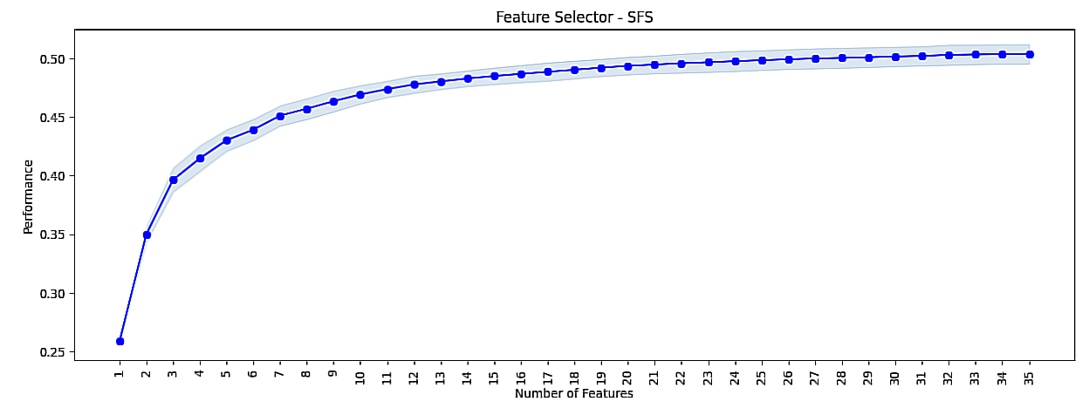

**55.feature_index = list(sfs.k_feature_idx_)**

**print(feature_index)**



**56.X_train.columns[feature_index]**

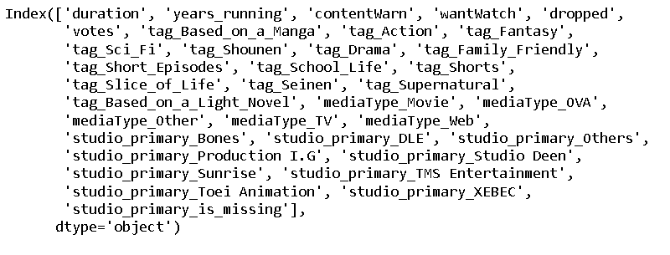

**57.X_train_final = X_train[X_train.columns[feature_index]]**

**X_test_final = X_test[X_test.columns[feature_index]]**

**58.lin_model_v2 = LinearRegression()**

**lin_model_v2.fit(X_train_final, Y_train)**

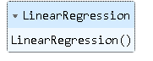

**59.print("Training Data Performance")**

**lin_model_train = Model_performance(lin_model, X_train, Y_train)**

**lin_model_train**

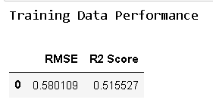

**60.print("Training Data Performance")**

**lin_model_train = Model_performance(lin_model, X_test, Y_test)**

**Lin_model_train**

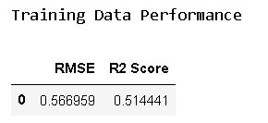

**61.X_train.columns[feature_index]**

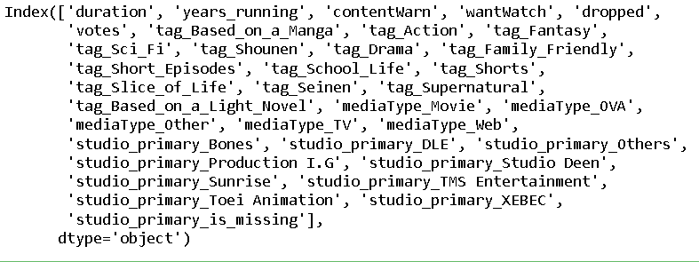

**62.X_train.head(2)**

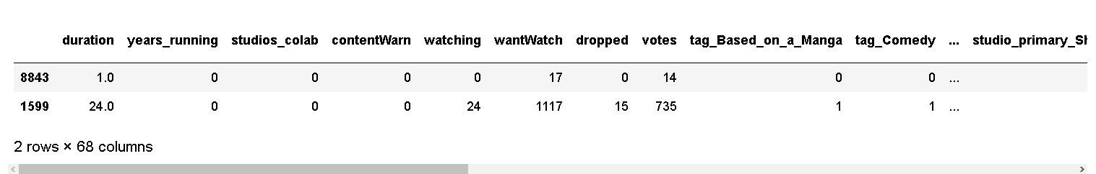

**Created by devendra ambre tybca sahyog college .**

**\*\*\*\*\*\*\*\*\*\*\*\*\*\*\*\*\*\*\*\*\*\*\*\*\*\*\*\*\*\*\*\*\*\*\*\*\*\*\*\*\*\*\*\*\*\*\*\*\*\*\*\*\*\*\*\*\*\*\*\*\*\*\*\*\*\*\*\*\*\*\*\*\*\*\*\*\*\*\*\*\*\*\*\*\***